How to use hidden services??

**May 19, 2022**

I ’ll begin by laying out the basics of setting up a VM, a web- servers and some retired services. I ’ll probably do this in a many posts, conceivably over a many days, so check back frequently.  
If you want to host a web- runner there are a many options available to you. One of the most egregious is to use commodity like foursquare or some other point-builder. Although this is a simple enough result there are a many downsides. Primary among these is the fact that you don't have the capability to do anything but what the provider (foursquare) offers. If you wanted to “ draw outside the lines” you may snappily find yourself up against some restriction.  
On the other- hand, tone-hosting your content gives you all the inflexibility you need as well as giving you the freedom to post opinions that your provider may differ with. I ’ll give a ( veritably) rough figure of what the way to do this are, also we will drill into each individual step latterly.

**Clearnet Setup**

The first many way will be to make content available on the clearnet.This will make your information available on the normal internet using the normal tools. You may choose to only host on the clearnet, or only host on the darknet. For this trial I ’m hosting on both.

Produce a VM  
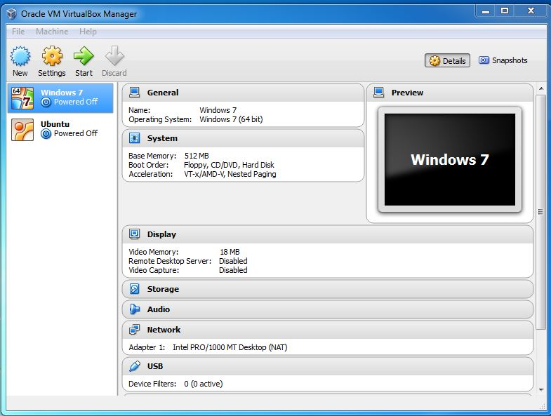

Hosting a website on anything other than a devoted web- servers is presumably not a good idea. Especially if you open the point up to the web at large. So in an attempt to find a cheep service, I choose Google ComputeEngine.However, you can generally stay enough near to the always free operation limits, If you're using the f1-micro preemptible image. I tend to run a many effects on GCE, but my bills are generally only a bone or two every other month or so. If you end up with a point that you want 24x7 up- time there are probably some plans from reduction providers at around$ 5/mo.  
   
Alternately you could use commodity like a Raspberry pi which you could spin up for$ 50 or lower, but it’s up to you.

Generating a Site

There are multiple options of site builders to choose from. I choose [Jekyll](https://jekyllrb.com/) because it is included in [Github Pages](https://pages.github.com/), and seems the simplest of the most popular solutions. This also allows you to mirror your self-hosted website onto Github hosted site through their github-pages feature. This provides a nice five-nine uptime site for clearnet use..

Choose a Web-Server

Firstly I smoothened over this piece, but shortly after hosting I noticed some really weird intrusion probing on my point and decided to rebuild from scrape. Opinions on which server software to run will vary hectically, but I ’m going to try lighttpd for the task. Crucial take down is that it has to have a small footmark and seems to be secure enough that our VM does n’t get overrun.

Choose a DynDNS

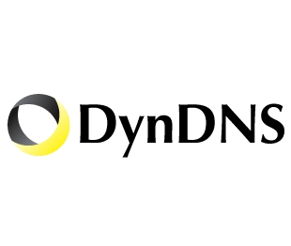  
This allows us to pick a point- name and stoutly modernize the IP address as our case moves. I know there are a many services out there, but I happed upon noip and have been enough happy with it. It gives me three records. I use one for the Github hosted runner, one for my tone-hosted runner, and I haven't yet figured out what to do with the third.  
• Installing NoIP Service-How to install noip as a service.  
DynDNS services are also useful for hosting on a jeer pi, since your home ISP will cycle IPs regularly.  
Configure Up- time Examiner  
Still, you'll probably want an over- time examiner to determine when your case preempts, If you're using the GCE and choose a preemtible case to lower costs. I was pleased to see that GCE integrates Stackdriver to allow you to recieve announcements when you're pirated. You can indeed renew your cases via the Android or iOS GCE mobile app.  
• Configure GCE Up- time Examiner- Step by step companion with Stackdriver.

**Darknet Setup**

At this point your clearnet point should be over andrunning.However, you can stop your web- servers and dyndns customer since they're only used for clearnet hosting, If you only want to host on the darknet.  
The darknet services will run commodity analogous to a web- servers, but for vary specific networks. I choose to run what looked like the three most popular darknet services. Important beyond this would start to make my poor f1-micro VM sweat.

I2P  
I set up I2P though Tor is more popular. There are numerous comparisons of I2P and Tor if your interested. The introductory difference I see is that I2P is peer-to- peer. All cybersurfers are also relays (if their anchorages are open). This is analogous to how bitcoin or bittorrent networks work. Tor on the other hand seems to have separate “ actors” and “ maintainers” orrelays.However, apre-packaged I2P installer is available, If your using Debian. Formerly installed, it's polite to open the I2P anchorages so that your knot can contribute to the network. Keep in mind that this will count against your VM’s bandwidth share, so it's commodity you'll want to keep an eye on.  
• Installing I2P Service-How to install the I2P service.

**Tor**

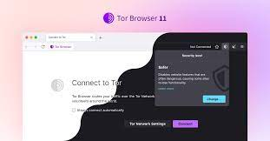  
By far the most popular darknet protocol, Tor has an intertwined and toughened cybersurfer as well as the escarpment service/ deputy. I swerved about from the normal install instructions and did everything through apt  
• Installing Tor Service/ Browser-How to install the Escarpment service and cybersurfer.

Freenet  
Of all the retired services, I plant Freenet to be the most intriguing. One of the coolest effects about freenet is that the content (if popular) will stay on the network indeed if the point/ servers that created the content goes down. Once content is on freenet it's imaged and participated by all the bumps and propagated.  
Installation on the VM was a little weird for freenet. Since I was trying to run as close to headless as possible, my JVM was throwing up some crimes. Luckily simply disabling availability features sounded to do the trick.

All Done

At this point you should have your point imaged on two clearnet services and 3 darknet services. Obviously this is way overabundance for a simple blog, but I demonstrate it simply to show how it can be done.